**Enhanced U-Net-Based Framework for Brain Tumor Segmentation in MRI Images: A Comprehensive Approach to Accurate and Precise Medical Image Analysis**

|  |  |  |
| --- | --- | --- |
| Bedadala Akhileswar Reddya,  *Department of CSE Amrita School of Computing, Bengaluru Amrita Vishwa Vidyapeetham, India*  BL.EN.U4AIE21021@bl.students.amrita.edu | Gopireddy Someswara Reddya,  *Department of CSE Amrita School of Computing, Bengaluru Amrita Vishwa Vidyapeetham, India*  BL.EN.U4AIE21054@bl.students.amrita.edu | Kollepara Lokesha  *Department of CSE Amrita School of Computing, Bengaluru Amrita Vishwa Vidyapeetham, India*  BL.EN.U4AIE21069@bl.students.amrita.edu |
| Tripty Singha,  *Department of CSE Amrita School of Computing, Bengaluru Amrita Vishwa Vidyapeetham, India*  [tripty_singh@blr.amrita.edu](mailto:tripty_singh@blr.amrita.edu) | Gayathri Ramasamya,  *Department of CSE Amrita School of Computing, Bengaluru Amrita Vishwa Vidyapeetham, India*  [iamgayathri@gmail.com](mailto:iamgayathri@gmail.com) | Dr. Nidhin Prabhakar T Va,  *Department of CSE Amrita School of Computing, Bengaluru Amrita Vishwa Vidyapeetham, India*  [tv_nidhin@blr.amrita.edu](mailto:tv_nidhin@blr.amrita.edu) |

**Abstract: MRI scans are a highly effective method for segmenting brain tumors, thanks to their superior soft tissue contrast and non-invasive approach. By producing detailed images of the brain's structural components, MRI scans utilize distinctive signal intensities to accurately define tumor boundaries. This valuable and high-resolution imaging technique is crucial for preoperative planning, treatment monitoring, and post-treatment evaluation. Ultimately, it plays a significant role in delivering personalized care and unique therapy options for individuals with brain tumors.The recent emergence of UNet, UNet++ has solidified its role as a dominant and highly embraced architecture for medical image segmentation. Its impressive ability to skillfully capture intricate spatial connections within images has propelled its popularity. By incorporating a distinctive U-shaped design, the model incorporates a contracting path for comprehensive context extraction and an expanded path for meticulous localization. As a result, UNet excels in gathering both overarching and precise details, making it ideal for distinguishing intricate structures within medical images. UNet's skip connections help keep important detail during the process of making and breaking up pictures. This makes segmenting things more accurate. UNet has shown that it's good at finding and separating cancers in many ways doctors use pictures. This makes UNet, Unet++ a strong tool used by medical workers to look more carefully at these types of images. So, we look into using Unet for brain mri segmentation. To do this better, we improve Unet, UNet++ by adding more layers on top of it.**

**Key Words:** MRI Segmentation, CNN, Brain Tumour, UNET, Dice Coefficient, Intersection Over Union

1. **Introduction**

MRI, which stands for Magnetic Resonance Imaging, is very important in health care. It can give clear pictures of our heads without hurting us. The ability to accurately divide and find different body parts in MRI brain scans is very important for doctors, scientists, and patients. Separating the brain into sections is very important in understanding how it's shaped and its problems. This helps find neurological diseases like tumors, disorders that harm nerves over time, bad head injuries and treat them better.

Brain tumors can form due to many reasons, and often we don't know exactly what causes them. Some cancers grow from problems with genes that cause cells to multiply too much. Other times, things in our environment might affect it. Being around radiation, some gene problems and a family history of brain tumors can make the risk even higher. Furthermore, age, gender and race could be important as different kinds of brain tumors are more common in certain groups. The brain and spinal cord make up the main part of your mind. If something goes wrong with how cells grow in these areas, it can result in a growth inside your head called a brain tumor.

There are many types of brain tumors sorted by where they come from, how active they are and their cell features. Brain tumors that start in the brain or nearby tissues are called primary. However, secondary ones come from other body parts and spread to the brain as metastatic cancers. Non-cancerous tumors called benign can slowly grow, causing a localized pressure. Bad tumors, in contrast, are harmful and can invade nearby tissues. This often results in more severe health problems. Common types are gliomas that begin with glial cells, meningiomas starting in the covering layers and pituitary adenomas coming from the pituitary gland. The signs and ways to treat brain tumors are different based on their type, place in the head, and how bad they are. Spotting problems early and acting quickly is important for good control and better results.

Different models have been used for brain MRI segmentation. Each one has its own advantages and uses. Convolutional Neural Networks (CNNs) are often used for dividing pictures, including brain MRI. U-Net, a special kind of CNN, has become famous for its ability in separating parts of medical pictures. The design called U-Net has parts for gaining a wider view and another part to focus in. This makes it very good at spotting things like shapes of the brain in pictures from MRI scans. Also, Recurrent Neural Networks (RNNs) are helpful when you need a system that remembers what happened before or can use information over time with healing imaging studies LSTM networks are good for splitting brain areas in time-based MRI images. These help us know how things change over many scans. Ensemble models, which use predictions from more than one model, can raise accuracy by using the power of different systems together. Furthermore, 3D CNNs are used for processing MRI data in a three-dimensional way so they can look at the relationships between spaces properly.

Our project uses the U-Net design, known for catching small picture details and keeping space info. This helps us in our work. This design is made of an encoder-decoder setup, with added skip links. It lets the system learn big and small details from MRI information. Our model is set up carefully, and we look through many different aspects to make it work as best as possible. The teaching process is done carefully, using modern methods in advanced learning. A good loss function, often Dice coefficient or cross-entropy is used to teach the learning process. The training data set is used to keep changing the model's settings using a helper like Adam, and a learning speed plan helps with reaching an answer quickly. Checking the model with new data is very important to avoid too much focus on one thing and measure how well it works in general.

We pick the U-Net, UNet++ model for its encoder-decoder structure and skip links to use it. This design is very good at keeping space details and seeing tiny bits. These are needed to split big brain parts in MRI images properly. In this research, we focus a lot on adjusting the U-Net's settings and improving its design to get great results in separating parts.

In summary, this project connects the latest technology with a very important area of medical pictures. The U-Net model's use for brain segmenting in MRI makes big changes to medicine. It can help doctors find illnesses faster, give more care and do research quicker while also helping us understand the complexities of human brains better over time.

1. **Related Works**

A special method to split brain tumors from 3D MRI pictures using a U-Net autoencoder design based on convolutional neural networks. The suggested way is to get a set of 3D MRI brain tumor images. Then, do things like making the pics same size and adding more versions before splitting them into a training part and testing one for learning stuff better. The U-Net model learns to see important things in pictures of tumors. It can then be used on new 3D MRI images to find the area around a cancer growth. The main goal of this study is to make a good tool for finding and treating brain tumors early on.[1] The main goal is to give a complete look at how deep learning methods are being used in MRI brain tumor image analysis today and why it's important. The study looks into the good and bad points of these computer programs, talks about their future possibilities for separating brain tumors in MRI. The study also looks at the ideas and benefits of convolutional neural networks (CNNs). It talks about mixing CNNs with other splitting up systems, such as Transformer, to make segmenting better. The work aims to give understanding of the latest research and future ideas for using deep learning methods in brain tumor part separation by MRI.[2] This lecture focuses on how important it is to use brain imaging that doesn't hurt, like magnetic resonance imaging (MRI). It helps us learn more about the structure and function of our brains. It shows the problems that come with looking at difficult MRI files by hand. It also points out how needed it is to use computer tools in order to find and study diseases better. The idea shows how important it is to get the brain MRI right. It influences many medical uses like measuring all parts of our brains, finding out faults and checking growth plus helping in making plans for surgery. The main goal of the work is to look at and compare popular brain MRI parts separation methods. It will show their differences, check how good they are, what advantages they have but also limits too. Also it covers important rules for doing these things right along with dealing with problems in this area called validation issues.[3] The goal of this document is to tell about an automatic way using a deep learning system called U-Net for separating parts in the brain of mice. The way it works is teaching a U-Net model to look at mouse brain scans that use DT-MRI. Then, we check how well it does compared with other top human brain separation methods using measures like Dice score, Hausdorff distance and average surface gap. The new way properly cuts the brain tissue without needing any hand fixes and is better than other methods.[4] The goal of this job is to show a new, patch-based method for CNN that can automatically separate brain parts in MRI without enough training. The practice includes teaching a CNN model on parts of MRI pictures, and then doing extra steps after that to get the final separation. The suggested way is checked against three types of CNNs and two ANNs. The results show that the new method gets higher accuracy in splitting things up.[5] In this paper, the writers show a way of splitting up brain tumors using Convolutional Neural Networks (CNN) with different types of MRI information. They compare two fusion approaches: early fusion and late fusion. The beginning fusion method is about teaching a big CNN with different MRI images of a patient. On the other hand, late fission happens when we train separate little and basic AI machines for each image type first, then mix high-level information at last before finishing separation. The writers solve a problem with different amounts of data in the book by using a method called patch sampling. [18]They also check how well other loss measures work, like dice, weighted cross entropy and focal losses. The part-splitting method is tested using a challenge set from BRATS2017. The findings are given as dice scores achieved by the trained network for each MR image sequence used in testing. The writers say that the late joining method, which works just as well but has more flexibility for mixing in all available MRI images.[6] The goal of the paper is to create a system that uses CNNs for accurately cutting out brain tumors (BT) from MRI pictures. The method uses ResNet and ResNeXt18 as the base for CNN-based BT testing. The job uses two types of information, BRATS2015 and TCIA-GBM. It checks if the suggested method works well with these datasets. We use the method to make things clearer in the test image. Then we check whether our CNN idea works well with these improved pictures. We check how well the new method works by looking at its results from getting back a detailed picture and comparing it to a cover photo. The findings show that the ResUNet method makes for better area separation than other older ways.[7] The goal of this paper is to make a smart system called Quicker Region-based Convolutional Neural Networks (Quicker R-CNN) for finding brain tumors in MRI data using deep learning techniques. The process needs to teach and check the classifier with a group of 3,064 brain images from MRI machines. The Quicker R-CNN method is set up using the TensorFlow tool. The method is checked by looking at a few things like how right it is, the correct number of results and more. These are called accuracy, precision, sensitivity and F-score in English. The findings show that Quicker R-CNN method gets a 91.66% accurate result, more precise than before with the same data set used in prior study.

[9] The purpose of this paper is to introduce a method for separating tumors using the U-net convolutional neural network. The writers want to make tumor separation better by dealing with the problem of uneven classes in their data set. They provide a strategy for balancing classes that chooses the area of interest (ROI) where cancer is found and continually tries to get an equal chance between tumor class and background. [17]A classifier called U-net is used. It has two parts: a contracting path to understand the main idea of an image and an expanding path that helps it find things in pictures more accurately. The best way is checked using quality numbers and compared to older methods, showing better results in correctness and how well it separates parts.[10] The goal of the paper is to create an efficient memory deep brain MRI segmentation system that can be used in medical applications. The suggested way, called FLBS, is based on the nnU-Net design and uses a series of 3D U-nets for dividing parts. The framework incorporates three main stages: pre-processing, segmentation, and post-processing. In the first stage, our brain images are changed into a standard space and their values are made equal. The part where you separate brain parts uses trained networks for each bit of the brain using gathered pieces. Lastly, in the step after prediction, we put together and sort out different labels. We also fix areas where disagreements happen using a simple shape method. The system is checked on sample MRI data and gets the same accuracy as top notch methods, but uses much less GPU power. It also keeps run-time length unchanged in a short time frame.[11] The goal of the study is to make patch-wise convolutional neural networks (CNNs) better at separating brain tumors in MRI pictures. The writers plan to study how different training situations affect the performance of the CNN model. They did tests to find out how training sample arrangement and patch size affected the results of dividing images. [16]The way they measured the similarity between regions and ground truth was using a score called Dice Similarity Coefficient (DSC). The tests were done using the BraTS2017 data set. This collection includes MRI scans of patients with high-grade glioma and different image types. The writers give some tips and plans for improving old models, as well as creating new CNN systems to separate brain tumors.[12] The goal of this study is to create an automatic way using MRI data that helps find brain damage caused by stroke in the right spot. The writers use a technique called deep convolutional neural network (CNN) built on the U-Net structure. They use a dataset open to the public to train the CNN and measure how well it works using numbers like accuracy and Dice Similarity Coefficient (DSC). The suggested way uses methods to increase information and adjusts it more closely, making segmentation results better. The writers compare their method with other approaches and point out the restrictions and possible chances of their study.[13] The aim of the study is to show a way for separating and classifying brain cancers in MRI images using methods based on Convolutional Neural Networks (CNN) and Support Vector Machine (SVM). The methodology requires three stages: pre-processing, CNN, and post-processing. Before using MRI images, methods like gradient field and intensity standardization are used to make the pictures better. Next, CNN is used to divide the tumor into two parts called high-grade glioma (HGG) and low-grade glioma (LGG). In the end, SVM sorting is used to find out if a tumor (harmless or bad) has happened based on factors we calculated. The given plan wants to make it better at finding tumors and help treatments work well.[14] The goal of the paper is to give a tool for dividing parts in MR brain images using deep learning methods. The writers change a top-notch type of neural network called Fully Convolutional Neural Network (F-CNN). They use slices from MRI scans to train it for semantic segmentation. They use the chances maps of a F-CNN as possible factors in something like Markov Random Field (MRF) to make equal volumes on space. The MRF is solved by using a method called alpha-expansion for getting close guesses about the results. The suggested way is tested using different ways of cutting data and shows good results in two brain MRI sets.[15] The goal of the paper is to provide a robotic way for checking brain problems in MRI pictures of people with multiple sclerosis (MS). The method uses a fully convolutional neural network model to separate the brain damage areas. The study comprises two datasets: one for learning and one for checking. The practice data set is made up of five people's scans with areas marked by an expert.[19] The test group has scans from people with MS who were diagnosed using the McDonald rules. The MRI scans are cleaned up by strong alignment, removing skull parts and fixing uneven brightness. The trained convolutional neural network is then used to split the brain's lesions. The size of these lesions can be measured by adding up all the parts found with it. We compare the results with measuring lesion size by hand.

The study of books has several ways to separate brain tumors in 3D MRI pictures by using convolutional neural networks (CNNs) and deep learning methods. Studies concentrate on making tumor detection more precise and fast. They show how important it is to find cancer early for quick treatment. Using U-Net designs is very common, showing they work well in training on pictures of broken tumor parts for correctly separating new MRI scans. The questionnaires look into the good and bad parts of many deep learning methods. This includes things like CNNs, U-Nets, ResNets and new ideas such as patch-based CNNs. The study looks at problems like too many rich people or not having enough learning things. It talks about ways to fix these issues, such as making the classes more equal and using small parts of training instead of big ones - this helps improve how well the segmentation works. Studies don't just focus on cancer parts, they also look into dividing brain damage from stroke cases and identifying the areas below where your thoughts happen. They can even check harmful changes in brains of people with multiple sclerosis automatically. The research also looks at combining CNNs with other networks and recommends memory-friendly models like Quicker R-CNN and nnU-Net for real medical uses. The studies show that computer methods are important for brain imaging without harm, telling us what's happening now. They talk about the issues and future chances in separating tumors from brains with MRI scans.

1. **Proposed Methodology**

Using a U-Net model to split the brain in MRI pictures is often done when working with medical images. The U-Net model is famous because it works well at doing picture splitting tasks. Here are the steps to follow for MRI brain segmentation using a U-Net model:

a. Data Collection: We gather a collection of brain images from MRI scans, along with related maps showing the divided areas in those pictures.

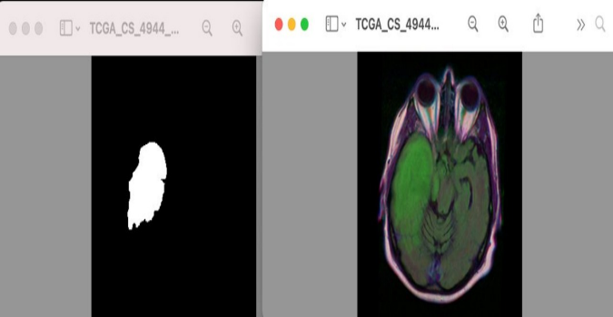

**Figure 1:Screenshot of the mask and MRI image in the dataset.**

b.Data Preprocessing: Make sure the MRI images and their labels have similar size, spacing and intensity by processing them first. Common preprocessing steps include:

Making all photos the same size.

Setting pixel values to a normal range (usually 0-1 or -1, +1).

To make your training data more varied, use techniques like turning it upside down, stretching or rotating.99+

c. Data Splitting: Divide your data into training, checking and test groups. A usual break might be 70% for training, 15% for checking and another 15% is kept back to test.

d. Architecture Selection:

**Unet :** The U-Net design includes two parts - an encoder and a decoder, with connections that skip over some steps. The machine lowers quality of the image using layers to mix and sort it. Meanwhile, another part raises this back up again by adding extra details to keep space information from getting lost. Batch normalization and ReLU activation are used all over the network. The model uses the Adamax optimizer with a learning rate of 0.001. The measures include rightness, overlap with size (IoU), Dice number and the section under a characteristic figure curve (AUC-ROC).

**Unet++ :** U-Net++ adds more convolutional parts to the U-Net building blocks. This is done by using more layers with normalization and leaky ReLU activations. Like U-Net, U-Net++ uses the Adamax optimizer with a learning rate of 0.001. The numbers used are correctness, Intersection over Union, Dice score and AUC-ROC.

e. Model Training:

Unet : The model gets trained for 50 rounds with a group size of 40. ModelCheckpoint and ReduceLROnPlateau are tools to save the best model and change learning rates

while training.

Unet++ : The U-Net++ model is trained for 50 epochs with a batch size of 40. It also utilizes ModelCheckpoint and ReduceLROnPlateau callbacks.

f. Model Evaluation: Check how well your trained model works using th test group of data. Common ways to check

performance in section splitting tasks are Dice score, Jaccard Index and Intersection over Union (IoU).

Dice Coefficient= ((2×TP)) / (FP+FN+(2×TP)))×100

Mean Iou=(union / Intersection)×100

Accuracy = (Number of correct predictions / total number of guesses) x 100.

Precision=((true Positives)+(false Positives+true Positives))×100

F1 Score=2×((precision×recall) / (precision+recall))×100

Recall=((true Positives)+(false Negatives+true Positives))×100

g. Visualization:Look at the parted results to see if they are right and true. Put the separated mask on top of the original MRI photo to check how good the separation is.

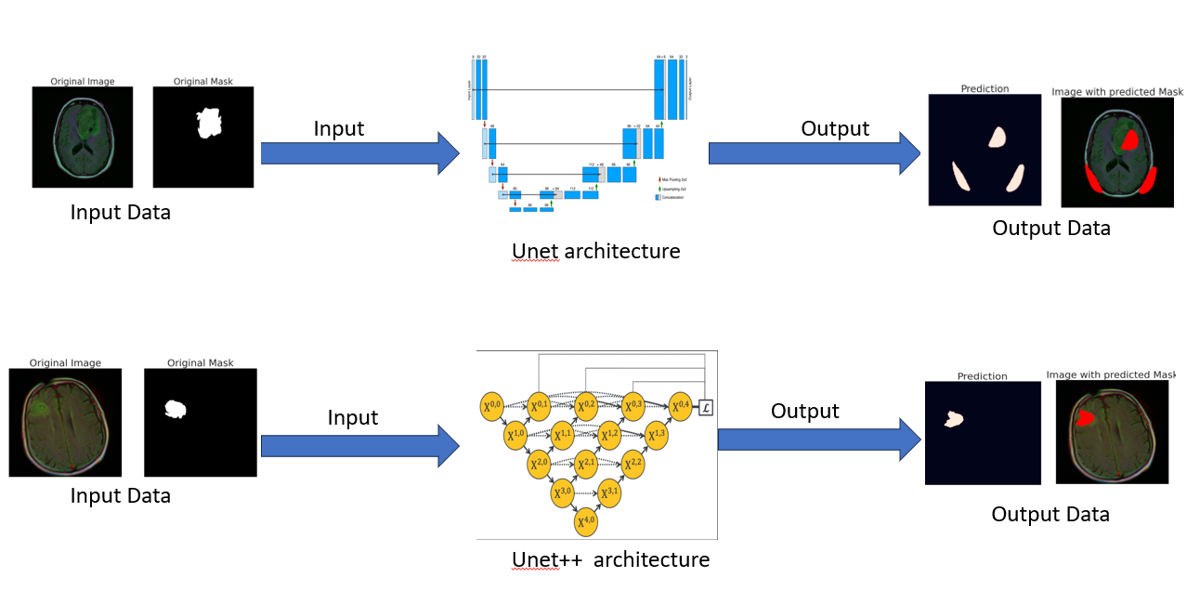

**Figure 2: Architecture diagram of Unet,Unet++**

**Results**

|  |  |  |
| --- | --- | --- |
| Metrics | Unet | Unet++ |
| Accuracy | 98.71 | 99.39 |
| IOU | 63.27 | 80.33 |
| Dice Coefficient | 77.48 | 89.08 |
| AUC | 0.95 | 0.9478 |

**Table 1: Results of Unet,Unet++ for brain tumor segmentation**

**Predictions of Unet Model :**

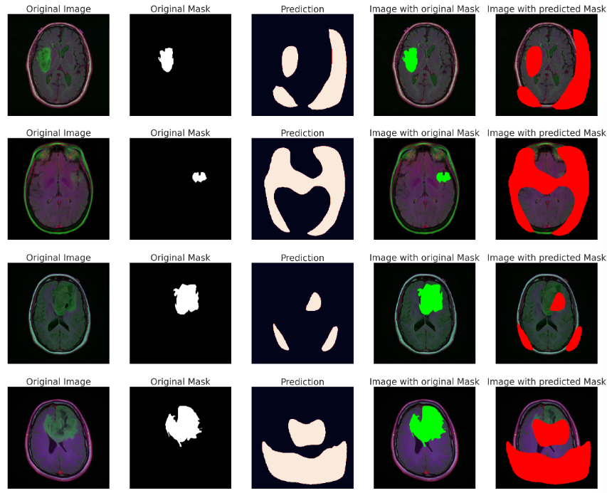

**Figure 3: Prediction of Unet Model for brain tumor segmentation**

**Predictions of Unet++ Model** :

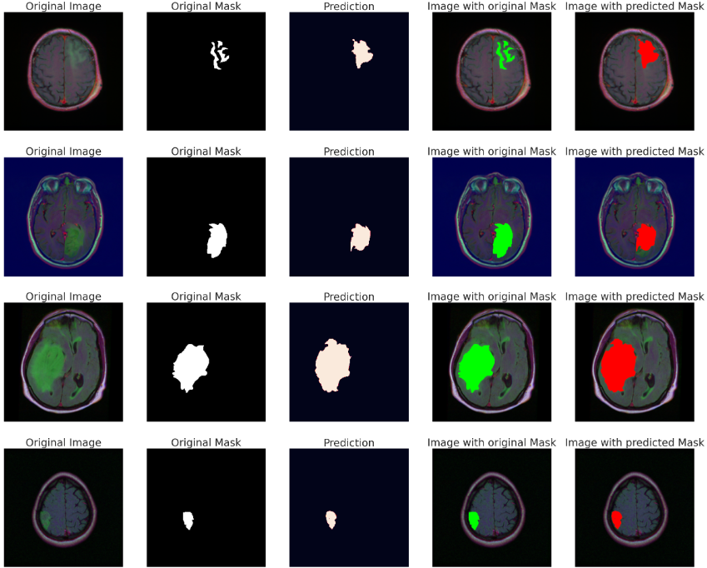

**Figure 4: Prediction of Unet++ Model for brain tumor segmentation**

In the part about results, the U-Net and U-Net++ models were tested really well. They checked them on different measures such as correctness, Intersection over Union (IoU), Dice number and a curve called AUC that is used to see how good they performed at classifying things right or wrong. Importantly, U-Net++ did better than U-Net in all areas. It proved to be much better at separating things when tested with several methods and measurements.

The U-Net++ has performed well with 99.39% accuracy, much higher than U-Net's score of only 98.71%. The IoU score, which shows how much predictions and real masks overlap, got much better with U-Net++ at 80.33%. But for U-Net it was just 63.27% lower than that percentage of correct overlaps between imagined results and what is true actually found in the data analysis work related to those concepts stated earlier using popular words easy to understand.

Likewise, the Dice score - showing how well predicted and real masks line up in space- showed that U-Net++ did a better job at dividing areas with 89.08% accuracy compared to U-net's rate of only 77.48%. For both models, the AUC results were similar. U-Net++ got a small edge with an AUC of 0.9478 while U-Net had an almost same score at 0.95. These results all show that U-Net++ is better at drawing object lines in image segmentation. It's a top pick because it can detect them correctly 99.39% of the time, which is very high quality and shows great success in what it does best!

1. **Conclusion**

In conclusion, U-Net and U-Net++ showed that they do better in image split tasks. This is because of having more accurate results, a higher ratio control telling how good one section was found versus wrong parts (IoU) and Dice coefficient metrics scores. U-Net++ proves it's good at finding where objects start and end in pictures. This makes it a strong choice for complicated separation tasks on advanced computer models. The small difference in AUC values means that both models are similar when it comes to how well they can tell things apart.

In future study, making small adjustments to settings and improving the structure of model designs could lead to better results. Using pre-trained weights on big datasets with transfer learning could help the models work better in different picture situations. Looking into different loss functions and ways to regularize can help us get better results when it comes to reaching higher accuracy in segemntation. Looking into how well the model works in certain areas or difficult situations within the data set can give clues about its good and bad sides. Lastly, putting the models to work on real-life data sets and checking how well they really do in hospitals or factories is key for useful use. In short, the results gotten help make future work better at using convolutional neural networks for picture separation tasks.

1. **References**
2. M. FARZANA, M. J. HOSSAIN ANY, M. T. REZA and M. Z. PARVEZ, "Semantic Segmentation of Brain Tumor from 3D Structural MRI Using U-Net Autoencoder," 2020 International Conference on Machine Learning and Cybernetics (ICMLC), Adelaide, Australia, 2020, pp. 137-142, doi: 10.1109/ICMLC51923.2020.9469580.
3. G. Liu and Y. Zhao, "A survey of deep learning methods for MRI brain tumor image segmentation," 2022 4th International Conference on Machine Learning, Big Data and Business Intelligence (MLBDBI), Shanghai, China, 2022, pp. 318-323, doi: 10.1109/MLBDBI58171.2022.00069.
4. Ivana Despotović, Bart Goossens, Wilfried Philips, "MRI Segmentation of the Human Brain: Challenges, Methods, and Applications", Computational and Mathematical Methods in Medicine, vol. 2015, Article ID 450341, 23 pages, 2015. https://doi.org/10.1155/2015/450341.
5. A. Thai, V. Bui, L. Reyes and L. -C. Chang, "Using Deep Convolutional Neural Network for Mouse Brain Segmentation in DT-MRI," 2019 IEEE International Conference on Big Data (Big Data), Los Angeles, CA, USA, 2019, pp. 6229-6231, doi: 10.1109/BigData47090.2019.9005976.
6. Z. Cui, J. Yang and Y. Qiao, "Brain MRI segmentation with patch-based CNN approach," 2016 35th Chinese Control Conference (CCC), Chengdu, China, 2016, pp. 7026-7031, doi: 10.1109/ChiCC.2016.7554465.0
7. M. Rahimpour, K. Goffin and M. Koole, "Convolutional Neural Networks for Brain Tumor Segmentation Using Different Sets of MRI Sequences," 2019 IEEE Nuclear Science Symposium and Medical Imaging Conference (NSS/MIC), Manchester, UK, 2019, pp. 1-3, doi: 10.1109/NSS/MIC42101.2019.9059769.
8. R. Mohan, F. N. Hasson, H. A. Fadhil, R. Arunmozhi and V. Rajinikanth, "CNN Framework for Accurate Brain Tumour Segmentation from Enhanced MRI Slices," 2023 Winter Summit on Smart Computing and Networks (WiSSCoN), Chennai, India, 2023, pp. 1-5, doi: 10.1109/WiSSCoN56857.2023.10133859.
9. R. S. Prabha and M. Vadivel, "R-CNN Based Brain Tumor Segmentation Using MRI Images," 2022 International Conference on Futuristic Technologies (INCOFT), Belgaum, India, 2022, pp. 1-4, doi: 10.1109/INCOFT55651.2022.10094426.
10. E. Martinez, C. Calderón, H. Garcia and H. Arguello, "MRI Brain Tumour Segmentation using a CNN Over a Multi-parametric Feature Extraction," 2020 IEEE Colombian Conference on Applications of Computational Intelligence (IEEE ColCACI 2020), Cali, Colombia, 2020, pp. 1-6, doi: 10.1109/ColCACI50549.2020.9247926.
11. A. Nejad, S. Masoudnia and M. -R. Nazem-Zadeh, "A Fast and Memory-Efficient Brain MRI Segmentation Framework for Clinical Applications," 2022 44th Annual International Conference of the IEEE Engineering in Medicine & Biology Society (EMBC), Glasgow, Scotland, United Kingdom, 2022, pp. 2140-2143, doi: 10.1109/EMBC48229.2022.9871715.
12. M. B. Ali, R. A. Hamad and M. Ahmed, "Optimizing Convolutional Neural Networks for Brain Tumor Segmentation in MRI Images," 2018 International Conference on Computer, Control, Electrical, and Electronics Engineering (ICCCEEE), Khartoum, Sudan, 2018, pp. 1-5, doi: 10.1109/ICCCEEE.2018.8515826.
13. F. Aboudi, C. Drissi and T. Kraiem, "Efficient U-Net CNN with Data Augmentation for MRI Ischemic Stroke Brain Segmentation," 2022 8th International Conference on Control, Decision and Information Technologies (CoDIT), Istanbul, Turkey, 2022, pp. 724-728, doi: 10.1109/CoDIT55151.2022.9804030.
14. R. Vinoth and C. Venkatesh, "Segmentation and Detection of Tumor in MRI images Using CNN and SVM Classification," 2018 Conference on Emerging Devices and Smart Systems (ICEDSS), Tiruchengode, India, 2018, pp. 21-25, doi: 10.1109/ICEDSS.2018.8544306.
15. M. Shakeri et al., "Sub-cortical brain structure segmentation using F-CNN'S," 2016 IEEE 13th International Symposium on Biomedical Imaging (ISBI), Prague, Czech Republic, 2016, pp. 269-272, doi: 10.1109/ISBI.2016.7493261.
16. M. d. Oliveira et al., "Quantification of Brain Lesions in Multiple Sclerosis Patients using Segmentation by Convolutional Neural Networks," 2020 IEEE International Conference on Bioinformatics and Biomedicine (BIBM), Seoul, Korea (South), 2020, pp. 2045-2048, doi: 10.1109/BIBM49941.2020.9313244.
17. Babu, T., Singh, T. and Gupta, D. (2020), Colon cancer prediction using 2DRCA segmentation and hybrid features on histopathology images. IET Image Process., 14: 4144-4157. <https://doi.org/10.1049/iet-ipr.2019.1717>
18. Lijo, Jithy & Singh, Tripty & Bhat, Venkatraman & Kuriakose, Moni. (2020). Segmentation and Three Dimensional Visualization of Mandible Using Active Contour and Visualization Toolkit in Craniofacial Computed Tomography Images. Journal of Computational and Theoretical Nanoscience. 17. 61-67. 10.1166/jctn.2020.8630.
19. J. V. and Dr. Tripty Singh, “Segmentation and 3D Visualization of mandible using Active Contour and Visualization Toolkit in Craniofacial CT Images”, International Journal of Computational and Theoretical Nanoscience , 2018
20. N. Narmada, V. Shekhar and T. Singh, "Classification of Kidney Ailments using CNN in CT Images," 13th International Conference on Computing Communication and Networking Technologies (ICCCNT), Kharagpur, India, IEEE, 2022, pp. 1-5, doi: 10.1109/ICCCNT54827.2022.9984256.